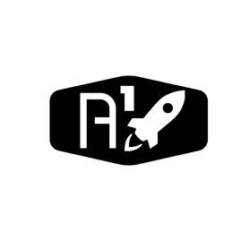

DESIGN DOCUMENT

Area : Converse Engine

Category: Feed (Avionics)

TEAM: Propulsion

Nyameaama Gambrah

**CONVERSE ENGINE CONTROL UNIT PROGRAM MODULES (ABSTRACTED**)

Tasks Manager

Testing

Rocket Central Computer

Testing

Entry

Feedback

Direct Feed

Measurements

On/Off

Open/Closed

Control Module

-Flowmeter -Pressure Transducer

-Thermocouple

Valves

Pump

Module Router

Measurement/ Analysis Module

Communication Module

Abort Manager